Original author: Christopher Moskaluk
Author of latest version: Christopher Moskaluk
Authorizer: Christopher Moskaluk, LCBRN Principal Investigator
Last review date: August 10, 2010

Purpose
Procurement of snap frozen tissue from surgical resection specimens containing lung cancer. This pertains only to subjects who are undergoing surgical resection for purposes of their clinical care, and for whom tissue is available from the procedure that would otherwise be discarded.

Responsibility
Tissue procurement personnel associated with the LCBRN Biospecimen Resource Sites are responsible for carrying out these procedures competently and safely. Data entry into the LCBRN online database may be carried out by different personnel than those entering data onto the LCBRN Tissue Collection Form at the time of procurement.

All personnel handling human biosamples must have training in, and adhere to, universal biohazard precautions and human subject research ethics/confidentiality principles.

Equipment/Reagents
- Lead pencil
- Digital scale capable of weighing milligram quantities.
- Protective gear (eye/faceshield, disposable gloves, appropriate lab attire).
- Sharp cutting instruments (scalpels, scissors, blades, etc.) for tissue dissection and sectioning.
- 10% neutral buffered formalin to fix tissue in cassettes
- Method of flash freezing tissue (liquid nitrogen, dry ice, etc.)
- An LCBRN tissue collection package containing: sample labels, three labeled “Polycon” specimen containers [1/4 oz, Madan Plastics), three labeled tissue cassettes, and a blank copy of the LCBRN Tissue Collection Form.

Procedure (also see Figures)
While no minimal time of procurement is specified, procedures should be optimized to allow tissue sample stabilization by freezing in the shortest possible time. Ideally, samples should be frozen 30-60 minutes from the time the specimen is removed from the subject.

- From the LCBRN subject enrollment package, obtain the tissue identification adhesive label for the subject and place it on the Tissue Collection Form. Enter the subject ID and the date on the form.
Note: The month is to be written out so there is no confusion between day and month entries e.g. May 6, 2011.
- Using a lead pencil, label the right side of the tissue cassettes with the date of procurement. See Figure 1. Note: Tissue cassettes MUST be labeled in pencil.
- Record time the specimen was removed from the patient on the Tissue Collection Form.
- Record time the specimen was received/accessioned in the Pathology Department on the Tissue Collection Form.
- Assist clinical personnel in the procurement of remnant tissue samples. While there is no minimal size requirement, the following are desired sample sizes when ever possible:
  - Tumor (T): 2-3 cm in diameter and 3-5 mm in thickness
  - Non-neoplastic lung (N): 2-3 cm in diameter and 3-5 mm in thickness
  - Non-neoplastic bronchus (B): 4-5 mm in length
- Record time the procured tissue sample(s) were received by the procurement personnel on the Tissue Collection Form. Record the person performing the procurement.
- Obtain representative tissue samples for histologic quality control (QC). For tumor and non-neoplastic lung, a central 2-3 mm strip should be sectioned from the middle of the sample, and then laid on its side in the appropriate tissue cassettes (see Fig. 2). For small specimens, an edge of the tissue may be taken instead of a central strip. Be sure that the appropriate tissue gets placed into the appropriately labeled cassette! T = tumor, N = non-neoplastic lung, B = non-neoplastic bronchus. For bronchial tissue, a 1-2 mm cross-section from one end should be obtained and placed in the appropriate tissue cassette (see Fig. 3).
- Record the weight of the remaining tissue samples (in mg) on the Tissue Collection Form. Blot the tissue prior to weighing to eliminate excess blood and bodily fluids. Note: be sure to properly tare the weighing container prior to measurement of tissue.
- The remaining tissue is placed in the appropriately labeled polycon containers, then snap frozen in a bath of liquid nitrogen for at least 1 minute. Alternatively, the polycon containers may be placed directly on a bed of dry ice or on a metal shelf in a -80º C for at least 10 minutes prior to final storage.
- Affix the labels for the tissue aliquots that were obtained to the LCBRN Tissue Collection Form. If a particular specimen type was not procured (bronchus for example) do not use those labels. Be sure that labels for both frozen and formalin-fixed tissue are placed on the form.
- Store frozen tissue samples at -80º C until shipment to the LCBRN Coordinating Center.
- The tissue in the cassettes is fixed in 10% neutral buffered formalin, then submitted for routine processing and paraffin embedding. The time the tissue spent in formalin is entered onto the Tissue Collection Form. Routinely, tissue should be fixed for 12-48 hours. Deviations from this routine (weekend samples, etc.) need to be noted.
- Enter data from the Tissue Collection Form into the online LCBRN database (see separate procedure). A barcode reader should be used to enter sample container identification using the duplicate labels affixed to the LCBRN Tissue Collection Form.
- Store the Tissue Collection Form with other subject study data paper documents in a secured location.

Figure 1
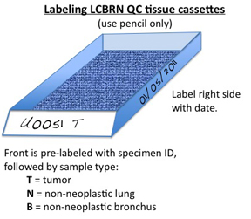

Figure 2
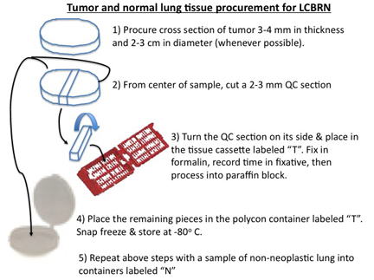

Figure 3
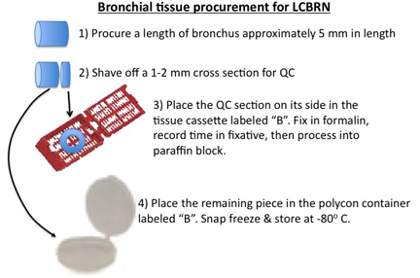

Change History
Version # | Significant change(s) | Author | Effective Date
1 |  | Moskaluk | 12/1/2010
2 | Handling of bronchial tissue. Labeling instructions. Figures updated. | Moskaluk | 1/2/2011
3 | Weighing instructions updated to obtain weight of tissue after QC sections taken.  Date entered on data sheets to have month in text, not numerical form.  Specification of 10% neutral buffered formalin for QC specimen fixation. | Moskaluk | 8/15/2011

